Renode Emulator

Steps:

1. Download the Renode from <https://renode.io/#downloads>
2. Follow instructions and ensure it is added to PATH
3. Open Watch Project (or other nRF Connect Project) on VS Code
4. Click the nRF Icon & Press Add Build Configuration

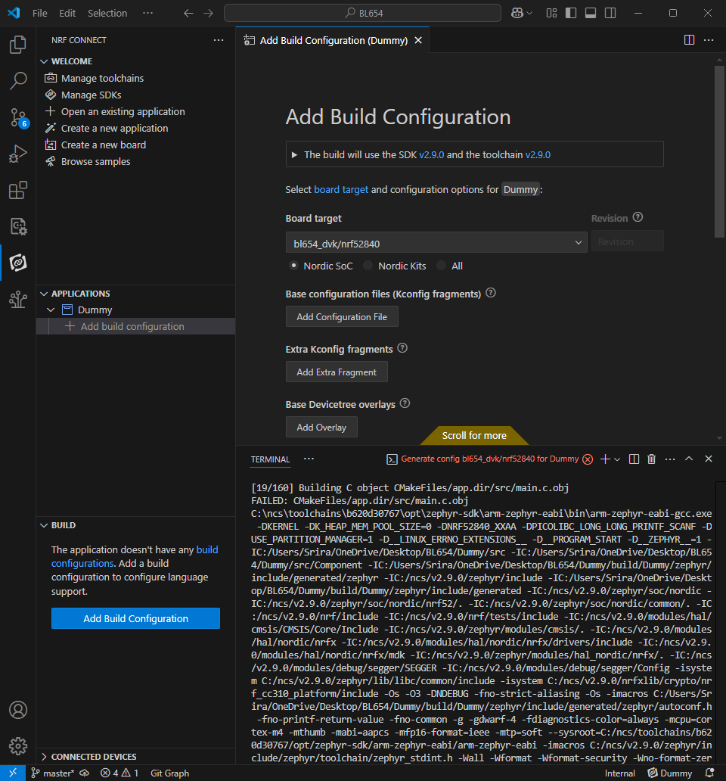

1. Ensure the build configuration is setup as followed:  
   A screenshot of a computer

   AI-generated content may be incorrect.
2. Press Build Configuration
3. Ensure that the project builds.
4. Open a VS Code Terminal and navigate the directory that holds the zephyr.elf.
5. Enter the following commands to emulate (in the given order):
6. renode –console
7. mach create
8. machine LoadPlatformDescription @platforms/boards/nrf52840dk_nrf52840.repl
9. sysbus LoadELF @./zephyr.elf
10. start
11. Here is a list of commands to emulate inputs and outputs:

* logLevel 1 gpio0